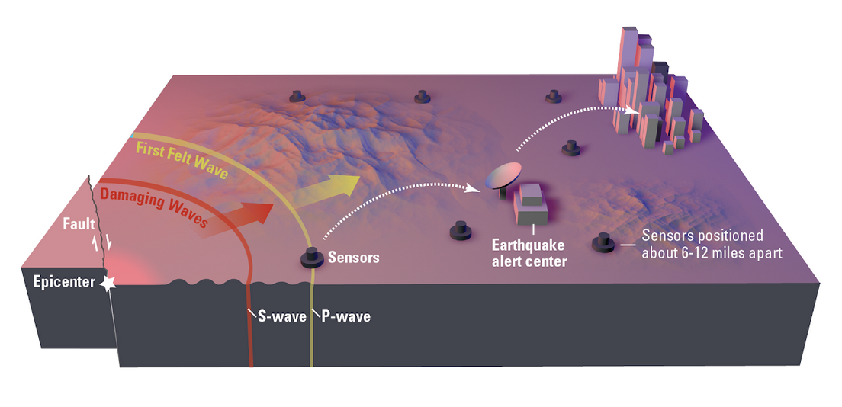

Seismic Prediction System

System Proposal and Design

Ryan Patton, Michael Thiemet, Gabrielle Davenport, Stephen Jason

# Executive Summary

Throughout the 2019 fall semester, our team worked to develop a system designed to detect earthquakes early on so timely safety and precaution measures could be taken. The following content illustrates the design process our team followed, outlining the system presented. Our vision is to develop an all-encompassing seismic prediction system to make the most use out of current available technologies.

**Customer’s statement of need:**

*There is a need to be able to predict a damaging future earthquake occurring in areas of dense populations. The ability to predict damaging seismic activity can allow for preventive actions to be taken by emergency personal, minimizing the likelihood of an adverse event taking place because of an earthquake. It is possible to measure shifts between the Earth’s tectonic plates and the subsequent seismic activity that is resulted from it, and use this data to develop a prediction of a likely location of an future earthquake. In 2016, the reported costs of natural disasters related to seismic activity in the Americas exceeded $50 billion dollars US.The system is expected to be used by government organizations as an effort to improve public safety in areas with large amounts of seismic activity, with the ultimate goal of protecting highly valuable assets and preserving human lives.*

**Design Summary**

The Earthquake Prediction and Notification System (EPNS) is a centralized hub to be used by geologists, seismologists, and government officials in order to detect and measure seismic activity. This data will be used to predict future earthquakes within a large enough time frame to notify affected populations, such that proactive measures can be taken.

1. Table of Contents

**1.** **Executive Summary 2**

**2.** **Project Schedule 5**

**3.** **Conceptual Design Phase 6**

3.1. Physical Subsystem Representation 6

3.2. KPP table 7

3.3. Stakeholder Requirements 7

3.4. System-level Analysis of Alternatives 7

*3.4.1.*  *8*

*3.4.2.*  *8*

*3.4.3.*  *8*

*3.4.4.*  *9*

3.5. Subsystem Analysis of Alternatives 10

**4.** **Preliminary Design Phase 13**

4.1. Functional Architecture 13

4.1. System Requirements 19

4.2. Functional Requirement Allocation 21

4.3. Physical Architecture 22

**5.** **Detail Design Phase 24**

5.1. Risk Management 24

5.1. Verification Plan 27

**6.** **Production Phase 28**

6.1. 3.1 Production 28

6.2. 3.2 Cost 28

**7.** **Maintenance Phase 31**

**8.** **References 31**

1. Table of Figures

Figure 1 - Project Phases 5

Figure 2 – General Timeline in Days 6

Figure 3 – Operational Overview of System 12

Figure 4 – KPP Table 12

Figure 5 - System Functional States 13

Figure 6 – Diagram of State 1: Normal Operation 13

Figure 7 – Diagram of Function 1.0: Activate Device 14

Figure 8 – Diagram of Sub-Functions 1.3 & 1.4: Conduct Self Test & Handle Self Test Results 15

Figure 9 – Diagram of Function 2.0: Sample Food Product 16

Figure 10 – Diagram of Function 3.0: Analyze Sample 16

Figure 11 – Diagram of Function 4.0: Inform Operator 16

Figure 12 – Diagram of Function 5.0: Store Results 17

Figure 13 – Diagram of Function 6.0: Go into Standby 17

Figure 14 – Diagram of Function 7.0: Maintain Device 17

Figure 15 – Diagrams of States 2 & 3: Charge Battery & Service Mode 18

Figure 16 – Physical Architecture 22

Figure 17 - Cost and Schedule 29

Figure 18 – Cost Calculations 30

Figure 19 – After Sales Support 31

1. Table of Tables

Table 1 - List of Abbreviations 5

Table 2 - Key Performance Parameters 7

Table 3 - Alternative System Comparison 9

Table 4 - Alternative Subsystem Battery Comparison 10

*Table 5 - Alternative Subsystem Display Comparison* 11

*Table 6 - Alternative Subsystem Sampling Mode Comparison* 11

Table 7 - System Functional Requirements 19

Table 8 - System Performance Requirements 20

Table 9 - System Design Requirements 20

Table 10 – Functional Allocation to System Design Requirements 21

Table 11 – Functional Allocation to Physical Architecture 23

Table 12- Risk Management 25

Table 13 - Risk Cube 26

Table 14 – Technical Performance Measures 27

Table 15 - Cost Assumptions 30

|  |  |
| --- | --- |
| Abbreviation | Definition |
| SD | Seismic Detection |
| GPS | Global Positioning System |
| KPP | Key Performance Parameter |
| MTBF | Mean-Time Between Failure |
| CDC | Central Data Center |
| EPCE | Earthquake Prediction Computation Engine |
| NS | Notification System |
|  |  |
|  |  |
|  |  |

*Table 1 - List of Abbreviations*

# Project Schedule

*Figure 1 - Project Phases*

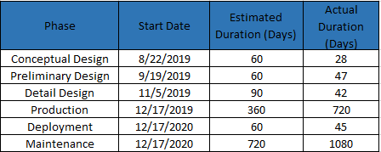

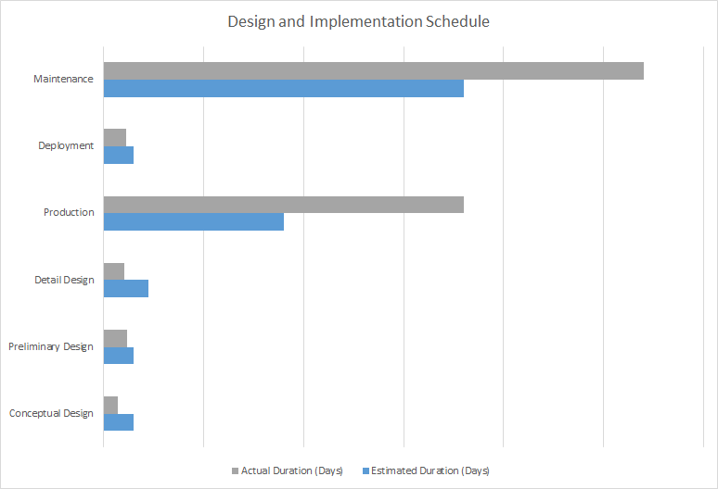

*Figure 2 – General Implementation Schedule*

Feasibility Schedule

a. 6 months for research/design/development

i. Trade Studies

ii. Key Performance Parameter (KPP) Comparisons

iii. Work Breakdown Structure

iv. Mission Concept of Operations

b. 2 months for prototype

i. Computer-aided Design

ii. Engineering Drawings

iii. System Schematics

iv. Integration Plan

c. 4 months for production

i. Order Parts

ii. Manufacturing

iii. Assembly

iv. Integration Troubleshooting

v. Software Development

d. 4 months for test

i. Test Readiness Review

ii. Test Suitability Requests

iii. System-Test Assurance

iv. Test Validation

v. Test Verification

e. 3 months for deployment

i. Environmental Conditions Assessment

ii. Troubleshooting

iii. Gather Real-Time Data

f. We predict a useful system lifecycle of 5 years

i. Assumes multiple refinement periods

ii. Accounts for unscheduled hardware and software maintenance periods

iii. Improved credibility from realized earthquakes while deployed

# Conceptual Design Review

## Conceptual Visual

*Figure 3 – Operational Overview of System*

## Description:

## Stakeholder Requirements

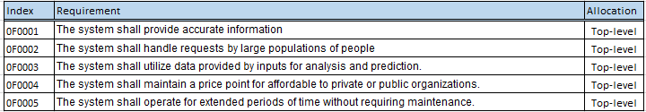

*Table 3: Stakeholder Requirements*

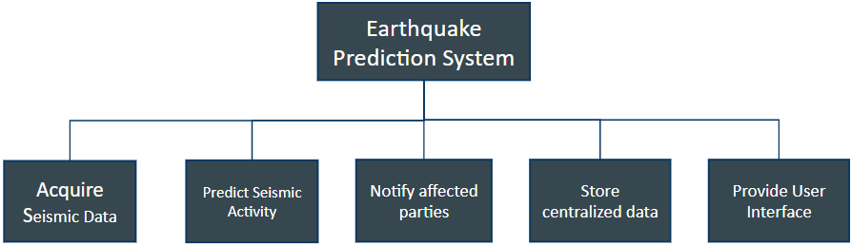

*Figure 4 – System Functions to Requirements*

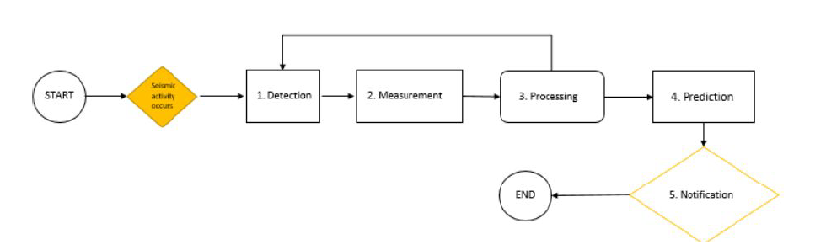

*Figure 5 – System Level Functional Flow Diagram*

In Figure 4 above, the primary system functions are described in each block. These functional blocks were used as inputs to generate our functional system requirements, classified with the “1FXXXX” designator. In Figure 5, the system level functional flow diagram is shown, which profiles the functions of the system, from seismic detection, to prediction, to user notification.

## Level 2 - System Architecture

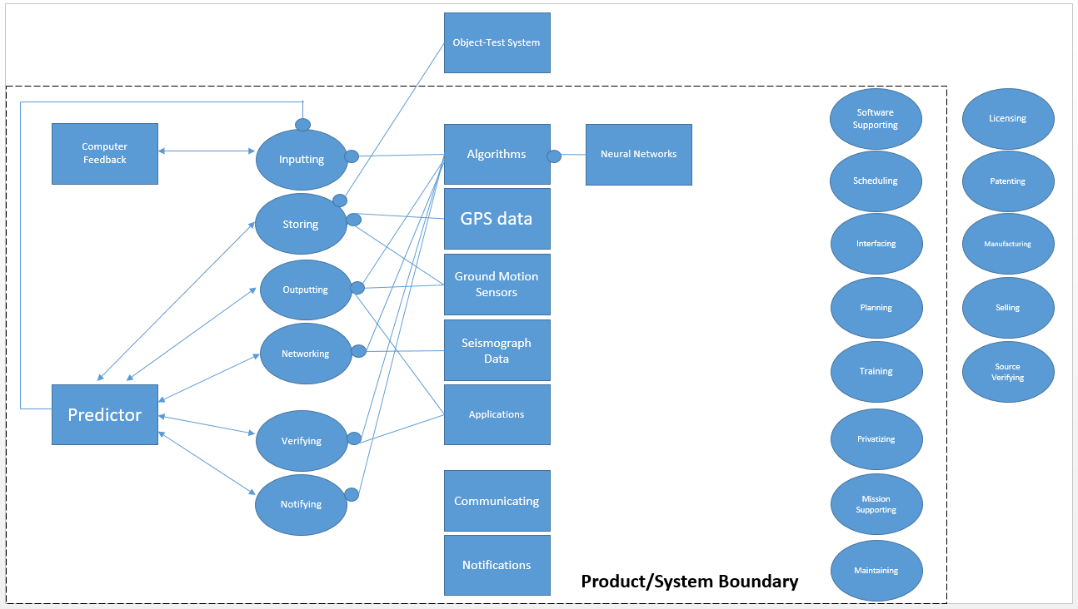

*Figure 6 – Level-2 System Architecture*

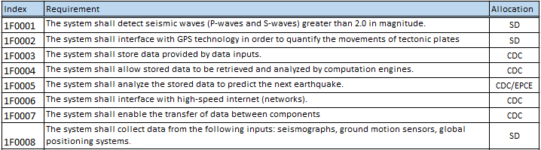

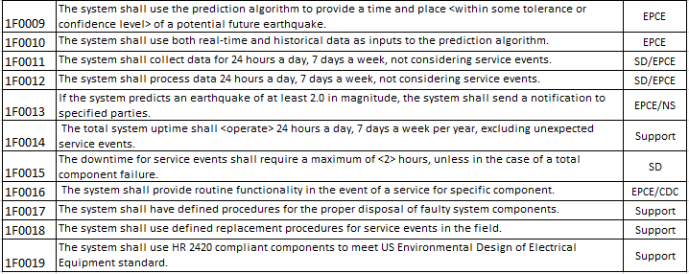

*Table 4: System Functional Requirements*

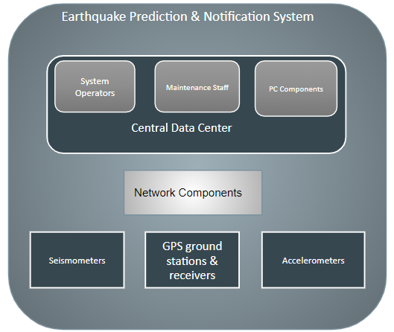

Figure 7: System Physical Architecture

## System Physical Architecture

The physical architecture of our system consists of 3 primary sensor components, network components needed to facilitate an extended network of transmissions between the components and the central data center, and the central data center itself. Our team envisions the central data center as being a physical location, which will serve as a workplace for system operators as well necessary maintenance staff. The heart of the system will operate from the central data center, where PC components responsible for the computation and prediction algorithms, notification functionality, data storage, and processing. The user interface of the system consists of PC command hub within the central data center.

Level 3 System Architecture

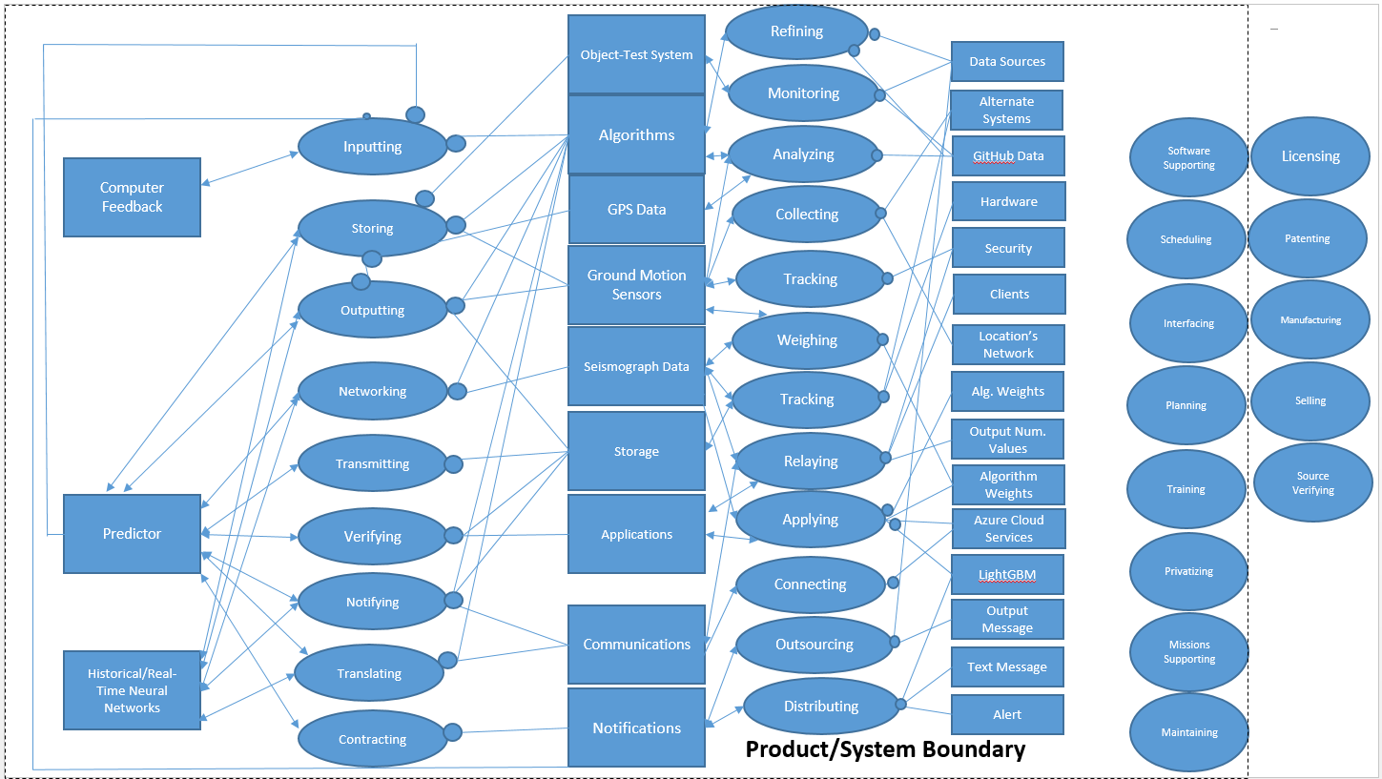

*Figure 8 – Level-3 System Architecture*

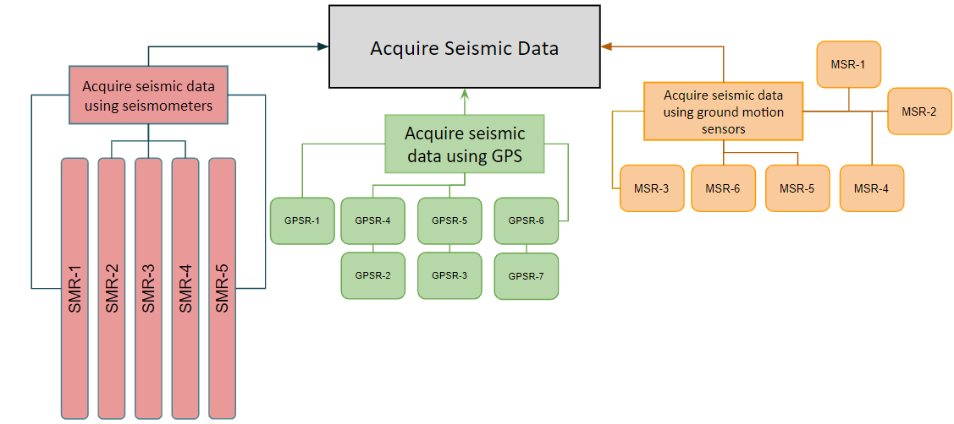

*Figure 9 – Seismic Detection Requirements*

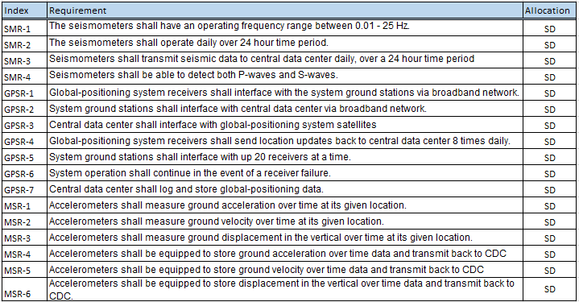

*Table 5 – Seismic Detection Requirements*

## 

*Figure 10 – Notification System Functionality*

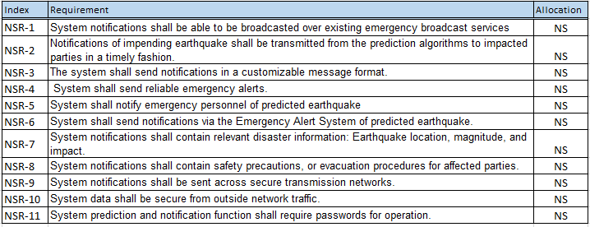

*Table 6 – Notification System Requirements*

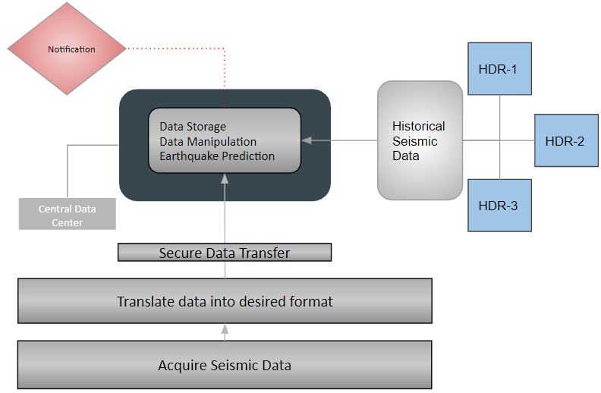

*Figure 11 – Data Migration through System*

## Description:

## Figure 11 describes the migration of data through the Earthquake Prediction System. After acquiring seismic data via the methods described in Figure 9, the data is translated into the desired format and securely sent back to the central data center. At this point, the earthquake prediction computation engine uses real time and historical data in order to determine the next seismic event. Once a defined threshold is reached, a notification of dangerous seismic activity will be sent to the necessary parties.

## 

*Table 7 – Earthquake Prediction System Requirements*

## Key Performance Parameters

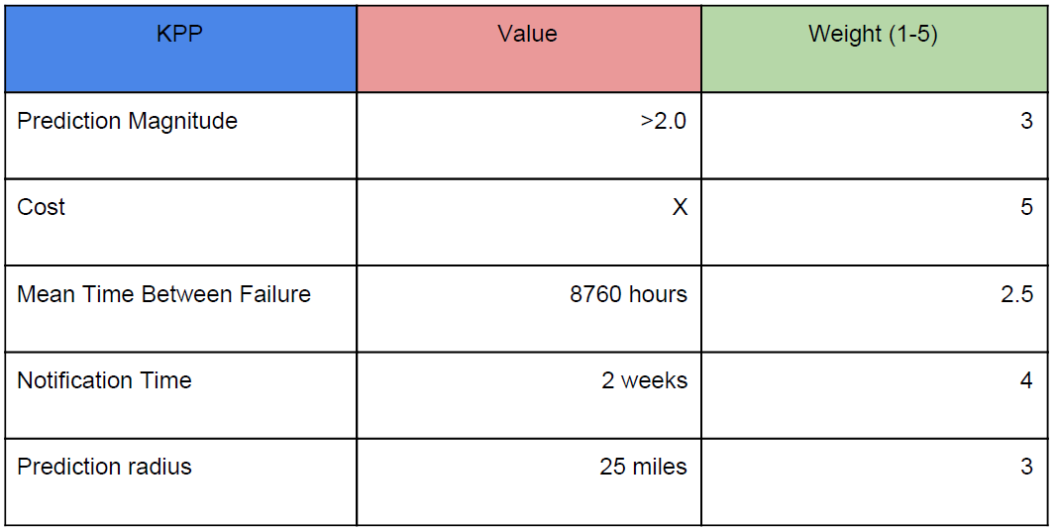

## Key Performance Parameter (KPP) Table

## 

*Figure X – Key Performance Parameter (KPP) Table*

KPPs Defined

1. The system will be able to make a prediction of future seismic activity greater than 2.0 in magnitude within a 2-week time frame, based on the input data provided.
2. The implementation of the system must use existing technologies in order to limit the cost of system infrastructure (no need for new measurement devices or seismic sensor stations).
3. The Mean-Time Between Failure (MTBF) for the system in hours, must be greater than 8,760 hours at the launch of the product.
4. The system’s prediction algorithm must be able to provide a location of the focus of seismic activity (epicenter) within 25 miles of the actual location.
5. The system will notify users if it detects seismic activity greater than 2.0 in magnitude (social media alert, text message, new alert, etc…).
6. The system will notify users if it predicts seismic activity greater than 2.0 in magnitude within a 2-week time frame (social media alert, text message, alarm notification, etc…).

## System-level Analysis of Alternatives

**Alternate Data Communication Options**

Many different information communication methods and sub-systems could be utilized. The hardware and software needed to receive and transmit vast amounts of data with fast upload/download speeds. Factoring into this consideration was the reliability of the hardware and software selected. The hardware is more directly related to budget constraints depending on the amount of computing power needed. The ease, familiarity, flexibility, and universality of C++ make it the perfect software language compliment to any hardware selection. The programmed hardware will communicate with data collecting sources and distribute algorithm outputs to the proper channels in an easy-to-understand format. The methods and channels by which the information will be collected and distributed is expanded on in the following sections. A detailed analysis of the considerations given for communication can be seen in Tables 2 and 3.

Table 2 - Alternate Information Distribution Methods with KPP’s

|  |  |  |  |  |  |  |
| --- | --- | --- | --- | --- | --- | --- |
| **KPP** | **KPP Rank** | **KPP Weight** | **Autonomous Source Monitoring** | **Direct Sensor(s) Comms.** | **Direct Fault Line Monitoring** | **Real-Time Monitoring** |
| Costly | 7 | 0.075 | 9 | 5 | 2 | 9 |
| Maintainable | 9 | 0.033 | 8 | 7 | 5 | 8 |
| Reliable | 5 | 0.10 | 7 | 8 | 9 | 5 |
| Proprietable | 3 | 0.15 | 9 | 4 | 8 | 9 |
| Future Growth Capable | 2 | 0.20 | 9 | 5 | 6 | 5 |
| Precisionable | 10 | 0.033 | 6 | 6 | 8 | 4 |
| Operable | 8 | 0.033 | 7 | 6 | 3 | 7 |
| Profitable | 1 | 0.20 | 9 | 4 | 4 | 6 |
| Versatile | 6 | 0.075 | 8 | 6 | 2 | 6 |
| Universal | 4 | 0.10 | 9 | 7 | 3 | 9 |
| Total |  | 1.00 | 8.5 | 5.4 | 5.3 | 6.7 |

Table 3 - Alternate Information Distribution Methods Feasibility Comparisons

|  |  |  |  |  |
| --- | --- | --- | --- | --- |
| **Criteria** | **Autonomous Source Monitoring** | **Direct Sensor(s) Comms.** | **Direct Fault Line Monitoring** | **Real-Time Monitoring** |
| Data transmittal  technology is  mature | 8 | 9 | 9 | 8 |
| Data transmittal  technology  directly  correlates to  earthquake  predictions | 9 | 9 | 9 | 9 |

**Autonomous Source Monitoring**

Autonomous source monitoring allows for both real-time data collection and improved

performance over time as it can learn from past data. The concept is extracting public data from many sources of information pertaining to earthquake monitoring and applying that data to a computational algorithm designed to earlier predict the chances of a catastrophic earthquake striking. The accuracy of the system improves over time as artificial learning techniques are applied and the system already has immediate value and a solid foundation to start from based off of the numerous sources of past earthquake data. The cost of the proprietary technologies are low due to its inherent value coming from the software designed to find variable comparisons where they may not be intuitive. As long as data is collected across each fault and shared, the program could apply that data to any fault and would not be limited to certain regions like other technologies. Once the program is up-and-running, its potential future growth is high because of the amount of publicly available data able to be inputted allowing for

improved variable causations and chance happenings over time.

**Direct Sensor(s) Communications**

Direct sensor(s) communications is a method of gathering earthquake data by networking a potential system directly to the sensors surrounding fault line areas of interest. The main benefit of connecting directly to pre-existing or new sensors is the ability to interact with the sources of data directly giving a sense of added credibility to the data. The relative uncostliness of adding a system’s own sensors increases the system’s worth because a wider net is cast for a proprietary domain. The technology on a surface level is practical but the ease with which the system could be duplicated is high. The number of available sensors around faults and one-dimensionality of the measurement method place burdensome limits on growth and development.

**Direct Fault Line Monitoring**

Direct fault line monitoring aims to maximize the number of ways to gather data by direct

observation along fault lines. Instead of just collecting data from sensors, the fault lines can be

tracked over time to monitor changes in their behavior. To properly observe the seismic activity

along faults where impacts would affect citizens and infrastructure, the costliness would be

absurdly high. Some points along faults are more susceptible to earthquakes than others

leading to the possibility of only covering some critical areas along the faults for observance but

the more areas losing focus, the more unreliable the system. Using the Global Positioning

System (GPS), fault lines may be tracked but the data correlating precision and accuracy of

tracking strictly behavior to the likelihood of an earthquake occurring is still in research and

development.

**Real-Time Monitoring**

Real-time monitoring originates from the same idea as an autonomous source monitoring

system but without the historical data for added convenience. A simplistic autonomous source

monitoring system offers benefits such as slightly reduced cost and accurate monitoring but fails

to significantly improve over existing technologies. With the primary goal of early detection as

possible, real-time monitoring does little systems in place can already do. The innovation

required for substantial profitability and future growth is limited by its ability to produce a better

system over time, even if big data can be inputted and outputted in a sensible manner

effectively.

**Alternate Notification Options**

Many platforms could be used to communicate the collected data to affected organizations and

people; television, application-enabled phone notifications, wide-reaching Internet domains, text

message alerts, and social media. The KPPs to compare the methods at the system’s

component level for notifications are as follows:

1. Cost: A measure of the cost of the component throughout its lifecycle as part of a system developed as a marketable product.
2. Reachability: A measure of the amount of market participants and organizations capable of receiving the earthquake notification with ample time.
3. Timable: A measure of how quickly the earthquake notification reaches members capable of receiving the communicated message.

Table 4 - Alternate Notification Options with KPPs2

|  |  |  |  |  |  |  |
| --- | --- | --- | --- | --- | --- | --- |
| KPP /  Alternative | KPP Weight | Television | App Notifications | Internet Domains | Text Messages | Social Media |
| Cost | 0.15 | 6 | 9 | 5 | 7 | 9 |
| Reachability | 0.35 | 4 | 8 | 6 | 8 | 7 |
| Timable | 0.50 | 4 | 9 | 6 | 9 | 6 |
| Total | 1.00 | 4.3 | 8.7 | 5.9 | 8.4 | 7.5 |

Application-enabled phone notifications is the best platform for communicating an impending

earthquake. Text messages and social media -- both aspects of smartphones too -- had

similarly high KPP weighted totals. However, creating a system that could send messages to

millions of phones in a short time frame would be costly. Furthermore, it may not reach people

away from their phones. Although billions of people worldwide across all socio-economic groups

have social media accounts, social media accounts are not always checked in a timely manner.

A key requirement of the system is its ability to communicate quickly with its intended audience.

**Alternate Seismic Detection Options**

With all of the seismic detection options available in different locations, the best approach to

detecting damaging earthquakes early on is to utilize as many resources as possible to gain a

better cumulative understanding and approach. All different kinds of seismographs and sensors

are readily available to perform their standard functions. The precision of standard instruments

credibly measure tremors but fail to correlate early enough how small tremors may build up to

severe tremors. Early improved interpretation of seismographs, sensors, and other

measurement forms whether through better placement near faults, better cross-analysis

between measurement devices, etc… will result in earlier accurate findings and open up earlier

communications with affected parties.

The sub-system options for seismic detectors will be analyzed on each of the following

Technologies:

● Sensors - strategically placed to monitor tremors near fault lines and interpret the

tremors numerically

● Algorithm Estimators - computational/mathematical attempts to predict when

earthquakes will strike next

● Seismographs - measures ground motion in combination with a recording device and

timing device

● Correlation of distantly related variables - assess possible leads of variables to improve computational/mathematical analysis not intuitively understood to affect earthquakes

such as climate near faults, weather, etc…

● Combined analytics - a systems-level computational approach to find better relationships between the different detections methods in place

From the listed sub-system alternatives, the following component-level KPPs help to categorize each:

1. Cost: A measure of the life-cycle cost of the component(s) needed to support the seismic predictor system.
2. Accuracy: A measure of how close to the actual magnitude the component gets
3. Operable: A measure of the time and effort needed to run and maintain the component
4. Speed: A measure of the rate the data may be uploaded to the system versus the rate of distribution of the pertinent information after computational analysis
5. Growth: A measure of the potential of the system to improve its marketability and profits

Table 4 - Alternate Seismic Detection Options with KPPs

|  |  |  |  |  |  |  |
| --- | --- | --- | --- | --- | --- | --- |
| KPP /  Alternative | KPP Weight | Weight Sensors | Algorithm Estimator | Seismographs | Related Variables | Combined Analytics |
| Cost | 0.125 | 2 | 7 | 5 | 9 | 7 |
| Accuracy | 0.20 | 8 | 3 | 8 | 2 | 9 |
| Operable | 0.125 | 8 | 5 | 8 | 4 | 7 |
| Speed | 0.30 | 4 | 8 | 4 | 8 | 8 |
| Growth | 0.25 | 6 | 9 | 5 | 7 | 9 |
| Totals |  | 5.6 | 6.8 | 5.7 | 6.2 | 8.2 |

A combined analytics approach is the preferred seismic detection method. Using a “best of both

worlds” approach, the system will input many different readings and sources of information,

tying them together in a way best suited for early detection.

**Additional Alternate Options**

The following subsystems require further trade studies and discussion to decide what the best

approaches will be for their system integration:

1. Data Storage/Processing: Additional studies will determine the best ways to analyze and process vast amounts of data input into a logical format.
2. Computation Engine: Additional studies will determine computational specifications and needed pseudo-algorithms to make early best predictions from the data.

After all subsystem decisions are made, a systems-level approach will guide the realization of

integration between the subsystems.

## Risk Management

Risks Associated with Seismic Detection

* 1. If seismic activity occurs outside our detection range, then it will not be included into the prediction algorithm
  2. If the thresholds for seismic detection are not well defined, then it could omit useful seismic data
  3. If the thresholds for seismic detection are not well defined, then it could include non-useful seismic data
  4. If seismic detection devices are placed in incorrect locations, then costs associated with technical development will increase dramatically
  5. If a detection component fails then the system will not be able to detect seismic activity in a given area

Risks Associated with Earthquake Prediction

* 1. If a detection component fails then the system will have to adjust the computation engine to handle the failure
  2. If the algorithm predicts an earthquake in the wrong location, then the system fails
  3. If the algorithm predicts an earthquake at the wrong time, then the system fails

Risks Associated with Notification Function

* 1. A notification of impending earthquake is not received in a timely fashion by emergency personal
  2. Notification system is prone to cybersecurity threats due to ability to send out emergency notifications

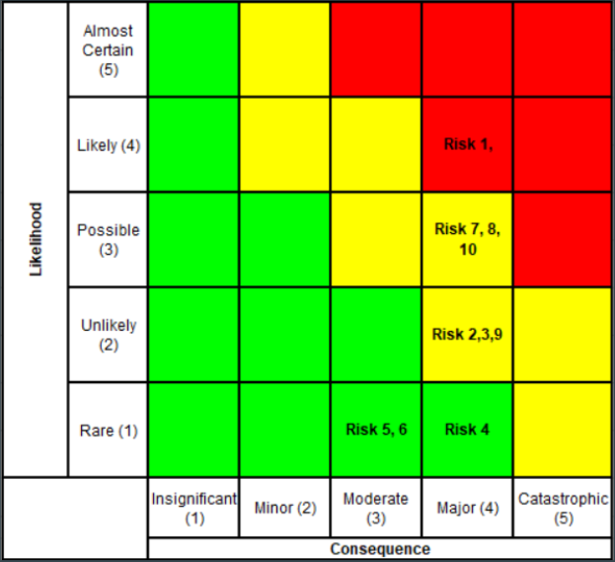

*Figure X – Risk Assessment Matrix*

## Risk Mitigation

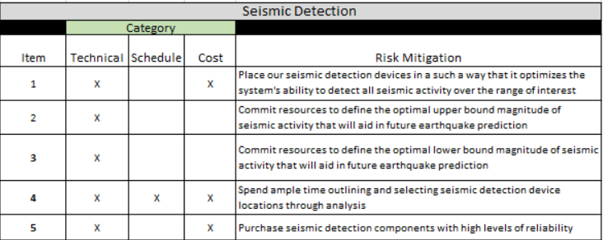

*Figure X – Risk Mitigation for Seismic Detection*

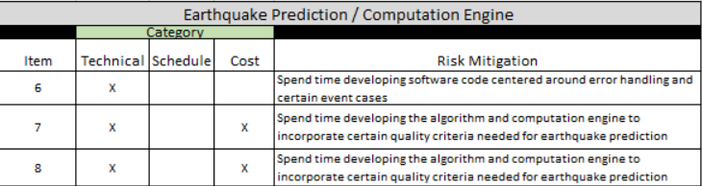

*Figure X – Risk Mitigation for Earthquake Prediction/Computational Engine*

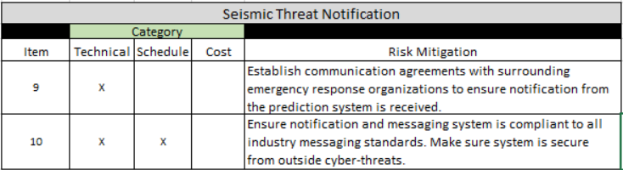

*Figure X – Risk Mitigation for Seismic Threat Detection*

## Verification Plan

|  |  |  |  |
| --- | --- | --- | --- |
| **Technical Performance Measure (TPM)** | **Quantitative Performance Requirement** | **Current TPM Value** | **Risk of Not Meeting TPM** |
| Percentage of earthquakes predicted within required time frame | Within 72 hours of predicted time vs. actual time | 95% within 72-hour window | 1 |
| Percentage difference between earthquake measured on Richter Scale and magnitude measurement of system | 2.0 magnitude on Richter Scale | 5% difference | 4 |
| Time improvement increments with number of GPS satellites utilized | GPS real-time lag time less than 120 seconds | 5 seconds per satellite added | 4 |
| Number of data sources | 5-10 Terabytes of storage allowed by computer(s) | 10 sources or more | 1 |
| Percentage of data relevant and practical for analysis | 5-10 Terabytes of storage software supports for analysis | 90% | 2 |
| Accuracy improvements in percentage with each data source added for analysis | Less than 60 minutes of analysis for each source of data mined | 2% or more | 2 |
| Number of people reached by notifications | Number of devices notified (1,000,000+) | 1,500,000 people confirmed | 3 |
| *1 = Very High, 2 = High, 3 = Moderate, 4 = Low, 5 = Very Low* | | | |

*Table X – Technical Performance Measures Evaluation*

## Test Plan

|  |  |
| --- | --- |
| **Quantitative Performance Requirement** | **Test** |
| Within 72 hours of predicted time vs. actual time | Feed historical data into system over a period of time that is similar to real time and see if the system flags an earthquake. |
| 2.0 magnitude on Richter Scale | Feed historical data into system and ensure it only flags data the indicates a potential earthquake with a magnitude ≥ 2.0 on Richter scale. |
| GPS real-time lag time less than 120 seconds | Time and record the lag time. |
| 5-10 Terabytes of storage allowed by computer(s) | Ensure storage is provided. |
| 5-10 Terabytes of storage software supports for analysis | Ensure storage is provided. |
| Less than 60 minutes of analysis for each source of data mined | Time the amount of time required for analysis. |
| Number of devices notified (1,000,000+) | Send out a test message to devices. |

*Table X – Tests Derived from Requirements*

## 

## 3.2 System Cost Breakdown

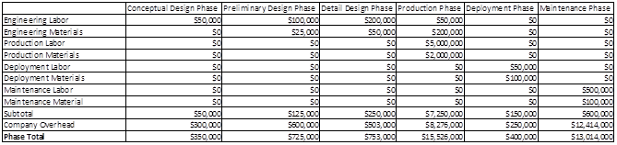

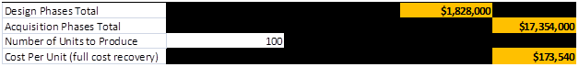

Table X: System Cost Breakdown

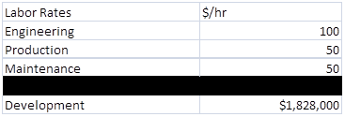

Table X: System Wage Scale

# Maintenance Phase

# References